|  |
| --- |
|  |
|  |
| Un pez de origami  Globers Assotiation – Spain  Facebook: https://www.facebook.com/ globers.net  Instagram: instagram.com/we_are_globers  Email: [globers@globers.net](mailto:globers@globers.net)  [youtube](http://www.youtube)  Sep 21  to  Nov 21  You(th) Pass in Europe with ESC 11 2020-3-TR01-ESC11-096473 |
|  |

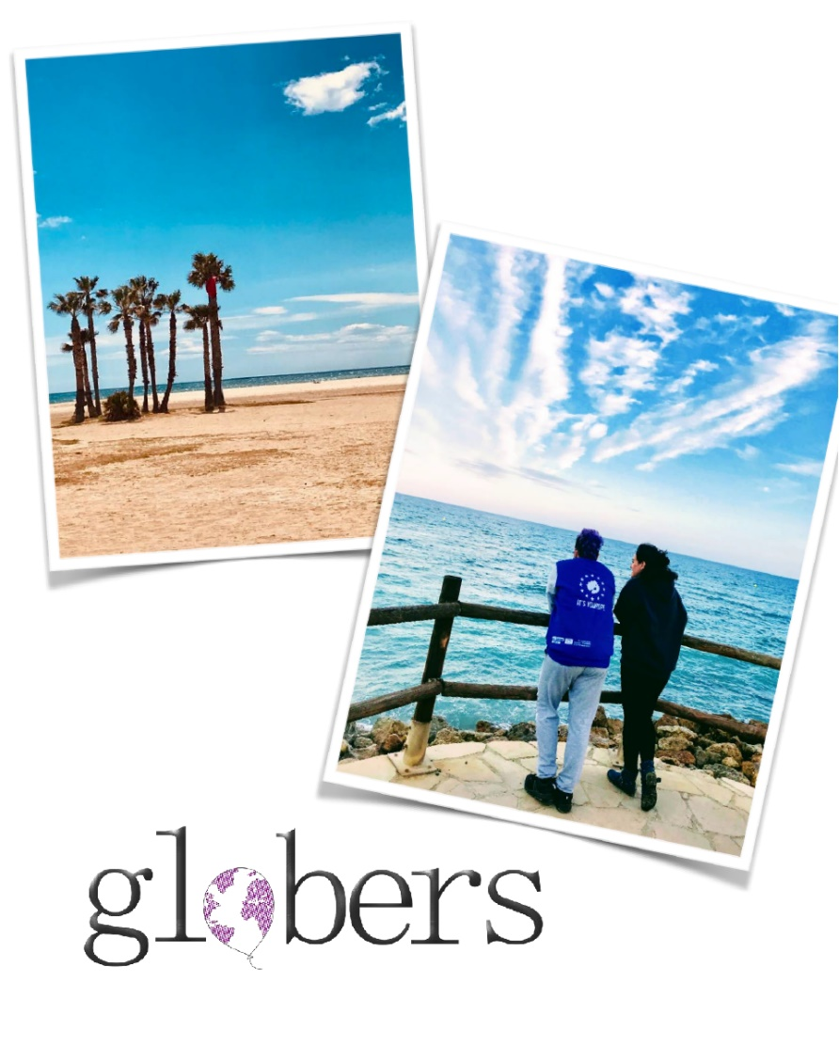

*“***Use your hands, your mind, your creativity and any**

**other skills you might have to support into hosting**

**group trainings and residencies, into the**

**enhancement of the place and into outreaching**

the local community.”

Become a Glober!

Live for 8 months in Tarragona, in an eco-place in northern Spain focusing on sustainability and to co-create our dream community with 2 more volunteers from Turkey.



Globers -the context

Globers is a peer-run social organization that develops capacity-building international programs. The institution is a young social start-up founded by professionals with more than a decade of experience in Erasmus +,Youth in Action, Euromed and other international programs.

Our trainings –life journeys– combines traveling & **non-formal learning experiences** shared with people from different backgrounds, in order to enrich dramatically your mind-set. Step out, become Glober!

Our eco-training center is located in a marine reserve area in the north part

of Spain. Our organization is built with lots of love and we work with a vision to create a place where sustainability meets tradition, culture and personal development.

The dream is that “**Globers is a place that belongs to its at-the-moment residents**”.

**Since 2017**, we have started hosting Erasmus+ projects in our town and this shifted a lot the general mindset around us. So, at the moment we co-host many events with the locals associations.

Unfortunately, Covid hit the place too. October 2019 was the last time an

international group had the chance to visit Coma Ruga for a residential learning

activity called ‘’Eco-Education’’

18 months later, **Globers is reopening** by hosting Volunteering programs and it is **ready to restart for one greener world!**

**Pillars of the project**

* **50%** of the project is focusing on 4 pillars supporting Globers and its activities happening in place or together with the surrounding community.
* **50%** of the project is focusing on creating a sustainable temporary eco-community consisting of the volunteering team

**1.Restart & Upgrade**

**2.Outreach the local society**

**3.Host groups and activities**

**4.Leave your own mark and beyond**

**1.Restart & Upgrade**

Hands-on actions and activities focusing on the **improvement of the place.**

It can be eco-building, gardening, opening paths, making wooden constructions and in general improving the infrastructure, the facilities and the sustainability factors of the place.

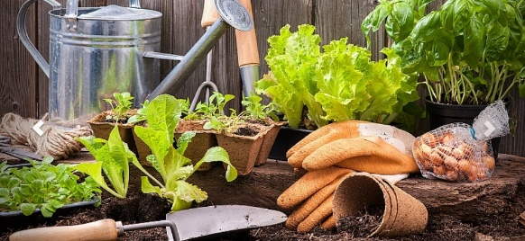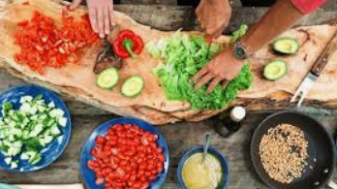

**2. Host groups and activities**

Covid allowing, during the 2 months we will have several groups visiting Globers for **learning**

**activities**. Most of these activities are connected in one way or another with the idea of sustainability.

As part of Globers team, you will be asked to support hosting these groups in several ways and according to your skills.

It can be preparing the place, cooking, delivering workshops or activities, tutoring them into task-related activities and in general supporting the hosting of those groups.

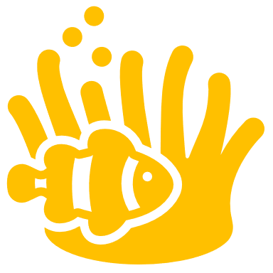

**3.Outreach the local society**

We aim to build strong **partnerships** locallly and plan common activities in general with the Marine Reserve and the local Youth Centre&City Hall

**4.Leave your own mark and beyond**

By joining this project you are already considered a “Glober”, the place also belongs to you. In order to support you with that, we encourage everyone alone or in groups to leave their mark.

It can be really anything as far as it is in line with the vision of Globers. It can be from a piece of furniture made of used pallets, a piece of art from repurposed materials, a drawing, to a video about Globers, a future project, a tree that you

planted, a strong partnership with another local or international initiative, a recipe book, a new NGO etc.

This includes **initiatives** not only during your stay at Globers but also afterwards for example to create a project for your community. Here the sky's the limit!  
Together we are stronger!!

**Globers - the Venture**

Globers home is a venture that aims at creating and supporting activities for parents, children and adults regarding the **Environment, Tradition, Culture and Personal Development**, while promoting sustainability at all levels.

It aims at setting an example of self-sufficiency in practice. Some of its main objectives are natural way of living, recycling, respect for nature & our marine reserve and reducing the ecological footprint.

**Profile**

18-30 years old

* Eager to learn or already have the knowledge or experience with the thematics of the project
* **Enthusiastic** with hands-on activities.
* Eager to take initiatives and create opportunities for themselves and society.
* Ready to live in a seaside environment with basic conditions for 8 months
* Ready to be challenged into aligning together with people from different cultures into making together a sustainable community.
* People with a clear plan and vision regarding their **participation in the project and beyond**.
* With at least B1 level English.

**Special skills**

Media skills such as photography and filmmaking for documenting this whole experience are welcomed too! **Therefore bring your laptop**!!

**Accommodation & Facilities**



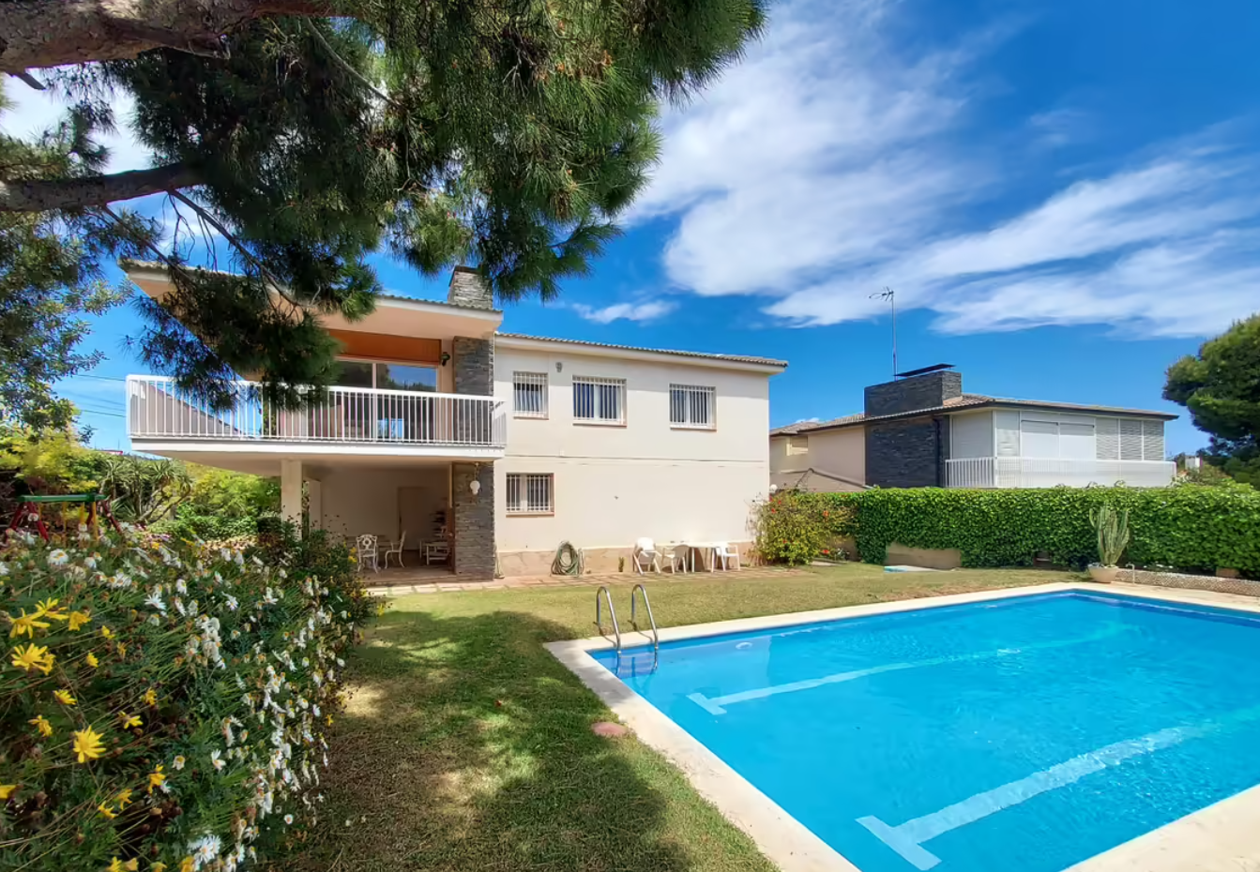

Globers home is located Avenida Masia Blanca , 23 in Coma-Ruga at the Gold Coast Tarragona. We are settle in a unique place **the protected MARINE RESERVE MASIA BLANCA**, one of the few Marine Reserves in Spain!!   
It is a spacious rural house surrounded by green areas and natural resources with which the project will interact. You will be sharing the comun spaces :rooms, toilets,kitcken living room, garden, swimming pool…Working rooms and spaces are settled at the venue for the project development. We are flexitarians ,therefore mainly veggi food.

**Practicals**

**Pocket money**: you will receive 5€/day

**Food money**: a weekly budget for all the group in order to cook altogether (for sustainability reasons)  
**Acomodation**:a shared room in a shared vila will all the amenities included  
**Local transport**:all activities are on walking distance,also shared bikes at your disponsal.

**Youthpass:** you are entitled to receive a YouthPass European certificate where you are expected to self-assess your own learning

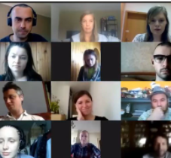

We are going to follow all the current Spanish legislation and take any required measures in order to prevent the spread of the virus.

You are asked to follow all the "at the time"/latest regulations to enter Spain according to the Reopen EU

<https://reopen.europa.eu/>.

We are going to use all the necessary precautions "at the time" needed interacting with groups (masks, gloves, sanitiser etc.)

The programme is originally designed without the influence of COVID-19 however sometimes plans need to be changed in order to adapt to the reality for this reason.

**Covid-19**

**Instead of Conclusion….**

Sustainability for us is the holistic idea to protect the environment, the economy,

and the people around us. This means that yes, we look for greener solutions in our

lives and the communities around us but also creating a balanced and harmonious

connection with each other and the people around us.

Globers has done some steps towards being sustainable. However, we are fully aware that we are not yet an eco-community nor 100% sustainable.

Our vision is to make every day a step towards this direction by shifting mindset

through experiential learning and we are inviting you to also contribute to this

action plan.

We are looking forward to creating this greener world together.



**Are you the next Glober?**

If what you've read so far resonates with you and you are ready to live and work for 8 months in Globers,then…